School Letterhead or use ARRL Logo Letterhead
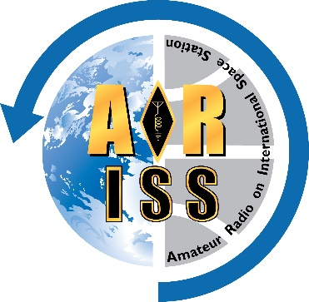
Contact: [LOCAL CONTACT’s NAME] [LOCAL CONTACT’s TITLE, if any}
[EMAIL]
[AREA CODE & PHONE]
FOR IMMEDIATE RELEASE

LOCAL STUDENTS TO TALK TO ASTRONAUTS ON INTERNATIONAL SPACE STATION
Amateur Radio connects kids, crew as ISS orbits overhead
[DATE]
Students at [NAME OF SCHOOL] at [ADDRESS] in [CITY, STATE] will talk with astronauts on the International Space Station via Amateur Radio at [LOCAL TIME} on [DAY, DATE]. This activity is part of the ARISS (Amateur Radio on the International Space Station) Program, which promotes learning opportunities as part of the STEM (Science, Technology, Education and Math) initiative.

[Describe students and teachers who have been preparing for the event. Describe some of the activities/topics they have been studying to prepare.]

[Describe how the contact will happen: Direct? Telebridge? Which astronaut will be interviewed?]

[Describe the local Amateur Radio community that will be supporting the Amateur Radio contact with equipment and any other support such as training students, providing instruction on radio communications.]

Background information to include:
What is ARISS?
ARISS is a joint venture by NASA, the Center for the Advancement of Science in Space (CASIS), the American Radio Relay League (ARRL), and the Radio Amateur Satellite Corporation (AMSAT) to facilitate communication via Amateur Radio between astronauts aboard the International Space Station and schools and communities around the world. ARISS programs excite and motivate students in a one-of-a-kind presentation and exchange.
ARISS program goals are:
- Inspiring an interest in STEM (Science, Technology, Engineering and Math) subjects and in STEM careers among young people.
- Providing an educational opportunity for students, teachers, and the general public for learning about wireless technology and radio science through Amateur Radio.
- Providing an educational opportunity for students, teachers, and the general public for learning about space exploration, space technologies and satellite communications.
What is Amateur Radio?
Amateur, or “Ham,” Radio, is a popular service and hobby in which federally licensed participants operate communications equipment. There are over 700,000 licensed amateurs and nearly 2,300 ARRL-affiliated Amateur Radio clubs in the United States. Hams talk to each other across town, around the world, and even into space without the need for normal communications infrastructure, such as cell phone networks or the Internet. Amateur Radio is regularly used during natural disasters to help local emergency and served agencies (such as the Red Cross, Salvation Army, and state and local governments) respond when normal communications methods are disrupted. The Amateur Radio community is a great source of electronics experimentation, public service, and fun.
More information on the ARISS program can be found at www.ariss.org.
More information on Amateur Radio can be found at www.arrl.org/what-is-ham-radio.
#####

