24 Hour Notice
24 hours before your ARISS contact, verify that you are ready by sending an e-mail to: 24hr-confirm@ariss-i.org AND to your ARISS program Technical Mentor.
You will need to include all of the information describe below. Use this template to make sure you include all of the information necessary.
Organizations not adhering to this e-mail request will be deleted as an ARISS scheduled contact!
Please include the following information in the email:
1) Organization name:
2) Confirmation that you are ready for the contact:
3) Time of contact (UTC & Local):
For a direct contact, run your tracking program to determine pass time.
For a telebridge contact, confirm the teleconference start time.
4) Phone numbers where the contact will take place. Include country code outside USA. Primary number:
Backup number(s):
5) Verify that primary phone does not have to go through a switchboard OR that the switchboard will have an operator present prior to and during the contact:
For a direct contact:
6) Station operator to make contact:
7) Call sign to be used at school:
8) Call sign to be used by ISS:
9) Transmit frequencies
Primary: MHz
Backup: MHz
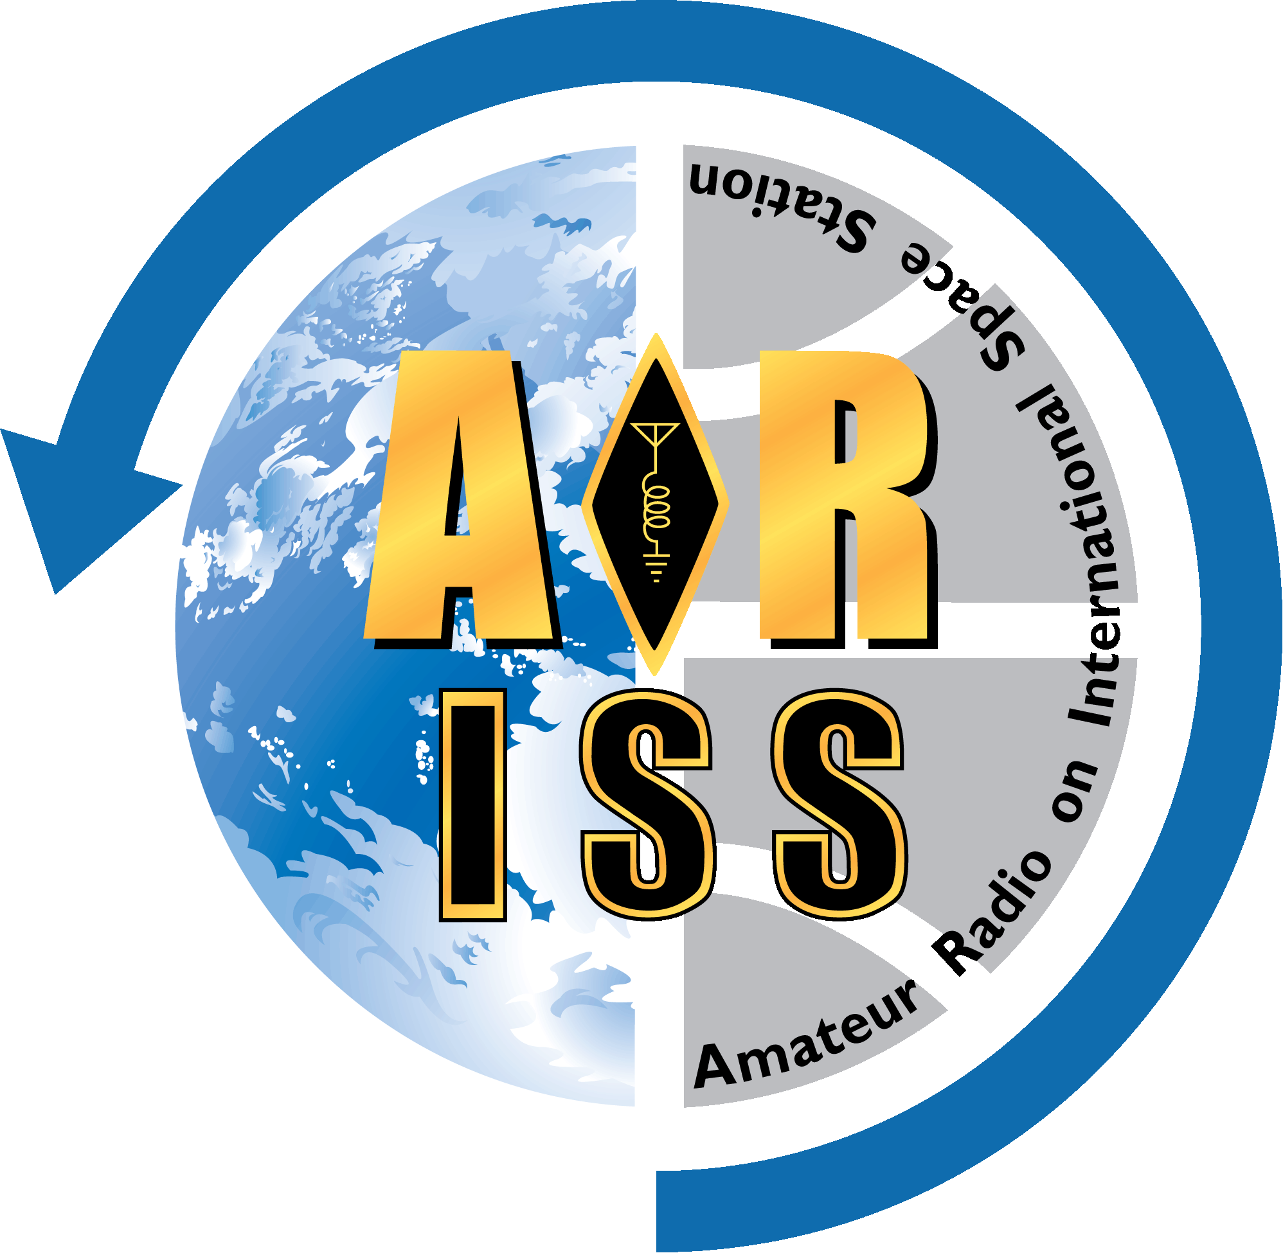For a telebridge contact:
10) Teleconference phone number:
Note: US and Canadian schools will call in. Schools in other regions will be called by the telephone operator.

